23 June, 2020

To: Sandra Kolvick, Carlos Diaz-Alfonso
Re: E4-Point Data Processing Algorithm

This document describes how data is processed within the E4-Point tool to convert from raw sensor data to clearances that are comparable with drop-checks performed manually. The code for the app is found in the GE Github repository here: https://github.build.ge.com/iacquire-grc/e4PtTool
This document will refer to files in this repository as appropriate. Note that the currently deployed version of the application is built from the devTesting branch.

Desired Calculations
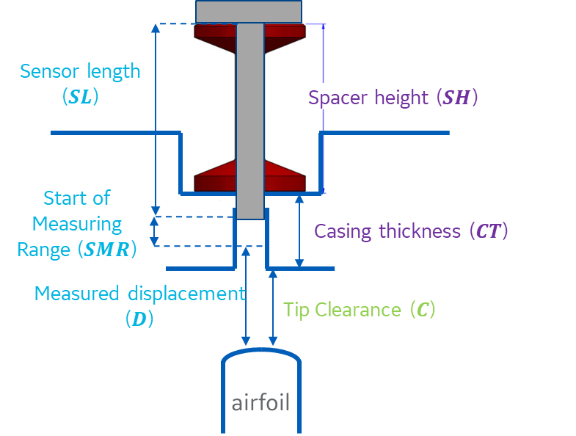
To convert raw sensor measurements to a blade tip clearance the necessary variables are shown in Figure 1.
Figure 1: Clearance Measurement Variables
The calculation for the desired tip clearance (C) in ideal conditions is then:

$C=SL+SMR+D-SH-CT$ ( 1 )
The measured displacement (D) is reported by the sensor directly. Initially this displacement was also a composite of a raw measurement and a Mastering Value. The mastering value allowed the sensor to be adjusted by placing an object in the measurement range of the sensor, and then “mastering” the sensor. This was thought to add a constant value to the output of the sensor allowing the user to perform a field calibration of the sensor before using it. This meant that D is a composite value of the sensor reading and some offset (MO). Therefore:

$D=d+δ$ ( 2 )
Where d is the distance measured, and $δ$ is the mastering offset. Once mastering was complete, the sensor only reported a displacement, D. This methodology was updated in 2022 to remove the “mastering” process because, according to the manufacturer of the sensor and controllers, masterin is a method to shift the zero point of the sensor, effectively adjusting your scale to allow for both positive and negative measurements. Mastering was replaced by a very similar process called the “operability check” wherein the sensor is placed in the fixture and a displacement measured. This measured displacement is then compared to a calculated displacement based on the known values ot sensor length, start of measuring range, and the fixture height. The op.check provides an early failure detection of the sensor by alerting the user to a measurement discrepancy that could be an indication of a failed sensor. Under real-world conditions all the variables in will have a tolerance associated with them so that ₁:

$C=(SL+δ_{0})+(SMR+δ_{1})+(D+δ_{2})-(SH+δ_{3})-(CT+δ_{4})$ ( 3 )

Since all the tolerances are constants, these can be combined into a single offset that is added to calibrate the sensor.
$C=SL+SMR+D-SH-CT+δ_{5}$ ( 4 )
However, a recent addition (around 2020) allows the app to directly pull the SL, SMR, and MR directly from the controller. This was accomplished by adding these parameters into the sensor serial number and then pulling them from the controller via the app. The E4-Point tool saves the SMR, SL, and $δ_{5}$ values in the file e4pt_config.js in a JSON object named “sensor_data” as follows:

sensor_data = {
'start_measurement_range':0.433,
'sensor_length':8.922,
'master_offset':-0.035
};
Where the hard coded values shown above are replaced with the parameters pulled from the controller. These parameters are precisely determined by Micro Epsilon (uE) and input into the controller as part of the standard work for these components. A QA/QC document has been created to help ensure these parameters are obtained and managed correctly.

In the e4pt_config.js file the spacer sizes are also stored in fixed structures for each frame size and casing thickness. Based on the user input for frame size, casing thickness and position, the spacer dimensions are looked up. This provides all the necessary measurements to compute the clearance except $δ_{5}$, the master offset. This value was acquired by putting the sensor into a fixture with a known distance to a surface (e.g. 5mm), performing a measurement and computing the difference between the reported value and the known distance. Assuming that the length of the sensor and mastering fixture are known to a very tight tolerance (fixture within 0.0003 in and sensor within 0.1mm), this will produce the final master offset which accounted for all tolerances and errors. If, after mastering the sensor, the measured distance matches the anticipated value, then the master_offset value is set to zero. As noted above, this mastering process was adapted into the operability check process. Currently the delta between measured and calculated displacements is discarded, but there may be use for it in order to reduce the measurement error intrinsic in measuring the sensor length, SMR, MR and fixture.

JavaScript Operation:
The user-interface is implemented in HTML (e4Pt.html) and controlled by JavaScript code found in e4pt_app.js. The code directly controlling the sensor and acquiring data is found in a Cordova plugin file written in Objective-C named CDVIFC242x.m. The JavaScript code passes messages to the Objective-C code which cause it to perform various functions. The Objective-C code passes messages, which may include data, back to the JavaScript. The controller interaction logic is defined in IFC242xManager.m.

For computing the clearance values, the JavaScript requests data acquisition. When the data has been acquired, it is passed to the JavaScript and the measurements extracted by the Objective-C code are calibrated using the known sensor and turbine data.

The object returned by the Objective-C code is a dictionary of data including an array of timestamps, point indices, raw displacements, filtered displacements, intensities and quality measures. The filtered displacements are the computed average value for each blade tip and are recorded only at those points determined to be valid blade tip measurement points. Points are considered valid if they are below a displacement threshold (deliminates the shelf from the tip of a squealer tipped blade) and their associated intensity values are greater than zero. The threshold is described under “Algorithm Breakdown” below.

The calibration of this data to produce clearance values happens in e4pt_app.js in a function named update_clearance on lines ~4095-4166.

This function makes sure that all calculations are done in consistent units (inches), and also watches for errors returned by the Objective-C. Errors are represented by a displacement value ≤-9.0mm.

Objective-C Operation:
Data is acquired from the sensor by the objective-C code (IFC242xManager.m). This code receives the raw data and processes it to find the blade tips. The data may be received via an Ethernet or serial cable. Serial Data is received and parsed by SerialController.m in lines 229-495. This is a process of finding and syncing to the first bytes in the serial transmission packet and extracting the data from multiple packets as they arrive. The serial data elements (displacement, intensity, etc.) are not necessarily aligned with the data packets that convey them. Data arriving via Ethernet is received and decoded by EthernetController.m in lines 348-439. In this case the data elements are contained in well-defined locations within the received packets.

In either the serial or Ethernet case the finding of blade tips is performed by PostProcess.m in the function named computeClearance at ~lines 76-305.

Algorithm Breakdown:
Line 88 -> Lines 307-336: In this section a histogram is populated with measured displacements from the sensor. This is a coarse histogram with bins ~1mm wide.
Line 93 -> Lines 343-415: In this section peaks in the histogram are found by finding maxima in the histogram. The top 3 maxima in the histogram are found by looking for peaks that are separated by ≥2.0mm. Currently this is an empirical value shown to provide good separation of data for squealer tips. (In the future this method may change if a more robust algorithm is found). The reason for this algorithm is illustrated below. In Figure 2 a series of data is shown for blades with squealer tips. It can be seen that the data groups into 3 groups: One group is at d=15mm, or “out of range”, one group is at the blade tips, and a final group is found at the “shelf” of the blade. The data for the tips can be segmented from the other classes by setting a threshold halfway between the tip values and shelf values. Data above the thresholds can be discarded and only the data at the tips is considered for computing tip displacement.

If the algorithms does not find 3 peaks separated by at least 2mm, then it is assumed that the blades are not squealer tips. The threshold is then set halfway between the “out of range” value (d=15mm) and the peak value in the histogram representing the blade tips.

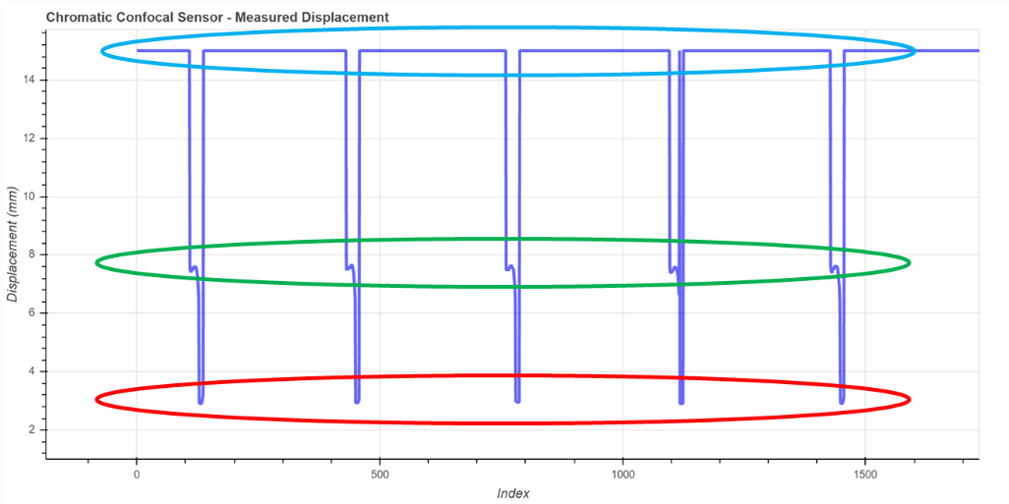
Figure 2: Sample data.
With the blade tips segmented the boundaries of each blade needs to be measured so that independent displacement measurements can be computed for each blade. To find the region of the blade tips the data is convolved with a 1-D Laplacian-of-Gaussian (LoG) filter. In computer vision 2-D LoG filters are commonly used to find region edges,. Finding the blade tips is a 1D version of finding edges in images. The LoG filter is computed in lines 471-497 using parameters for kernel size and kernel sigma that are hard-coded. The LoG filter used in this application has 13 elements and uses a kernel sigma of 2.8. These values were determined empirically and seem to yield good results. The kernel is plotted in Figure 3.

Figure 3: LoG Kernel
The LoG kernel is used to filter the data in the function fir_filter in lines 503-594. This function convolves the kernel with the data and returns the results. This operation is performed using the device DSP for faster processing. The output of this filter contains excursions through the y=0 axis at the boundaries of the blades. A negative excursion through y=0 corresponds to the beginning of a blade tip. A positive excursion through y=0 corresponds to the end of a blade tip. An example is shown in Figure 4. In this example the boundary of the entire blade is found, including the “shelf” region.

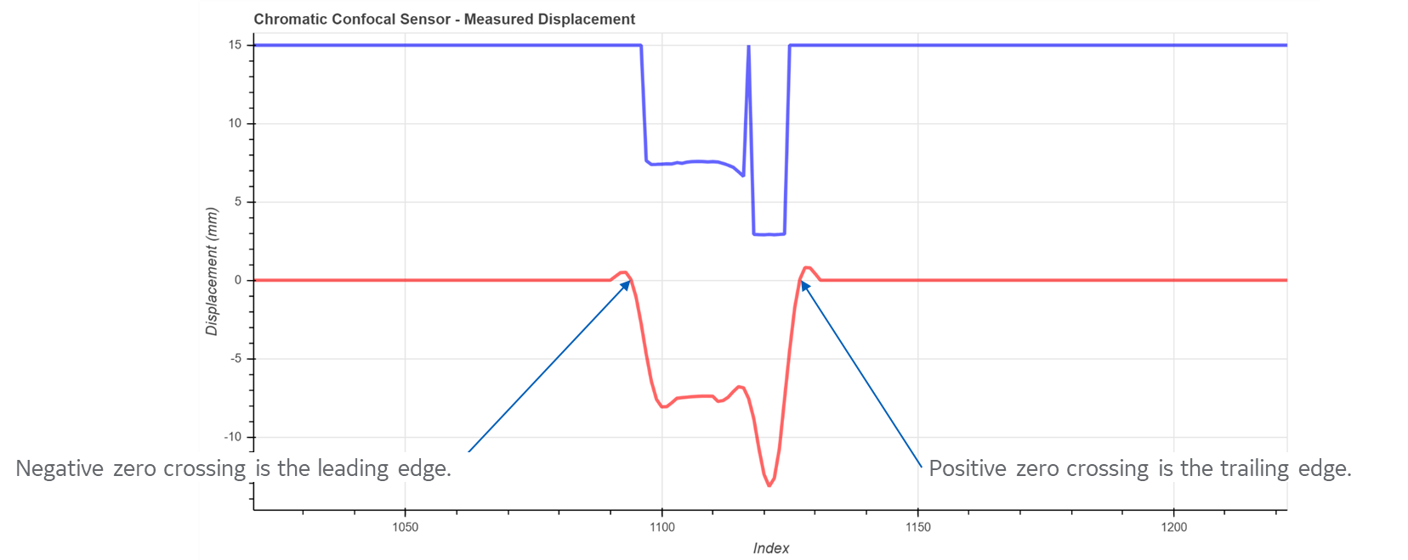
Figure 4: Sample output from LoG filter.
Once the blade tip boundaries are found, the zero-crossing locations are found by looking only at the sign of the LoG output signal. This is called at line 111 and happens in lines 435-452.

Next the displacements are summed for each blade (between the negative and positive zero-crossings). The sum is contingent on the displacement being between the zero-crossings and also having an intensity value > 0. As the blade displacement points are summed there is a parameter that allows the algorithm to discard a defined number of start or end points. This allows for a certain amount of error in finding the edges. If no points are found matching these criteria, the displacement is set to -9.996. This provides a way to identify a specific error if it should occur. If the count of points between the begin and end points is greater than zero, then the average of those points is computed and that is the displacement value for the blade. This process takes place in lines 184-238. Around 2020 this was modified so that if an airfoil has less than 2 measurements it is discarded as not being a viable measurement. In 2022 this was further updated to provide a method to change this value through the app settings rather than through the UI. This allows for greater maneuverability when troubleshooting the app. It is likely to be set to a constant value at the end of development to prevent too much variability in the hands of the operators. A sample of the output is shown in Figure 5 and Figure 6.

Figure 5: Raw and Filtered Data

Figure 6: Magnified View of Raw and Filtered Data
To identify and call out blades where the data is noisy, a quality metric is defined for each blade tip. The quality metric is the percentage of points whose values are ≤0.001” from the mean of the points for each blade. If this percentage is <1.0 then this fact is reported back to the user through the UI. This takes place on lines 255-257. This quality metric has proven to be largely ceremonial in the measurement. It will likely be discarded prior to deployment.

The final displacement for a full stage is computed by averaging all blades across the stage. There are different ways these averages are computed.
- If a frame and stage is defined with a known number of blades, N, then only N displacements will be averaged to produce a final result. This avoids including blade tips more than once, which could give undue influence to a single blade.
- If the number of blades, N, is known, but the algorithm found fewer than N blade tips, then all blade tips will be averaged to produce the final result.
- If a frame and stage are not defined, then all the blade displacements will be averaged to produce the final result.
These conditions are implemented in lines 239-304. Once the blade displacements are computed they are returned to the JavaScript code for computation of the final, calibrated clearances.

The clearances are then reported to the user through the UI.

Figure taken from a slide created by Brooke Schule as part of her Edison rotation report-out.
https://academic.mu.edu/phys/matthysd/web226/Lab02.htm
https://users.fmrib.ox.ac.uk/~steve/review/review/node13.html

